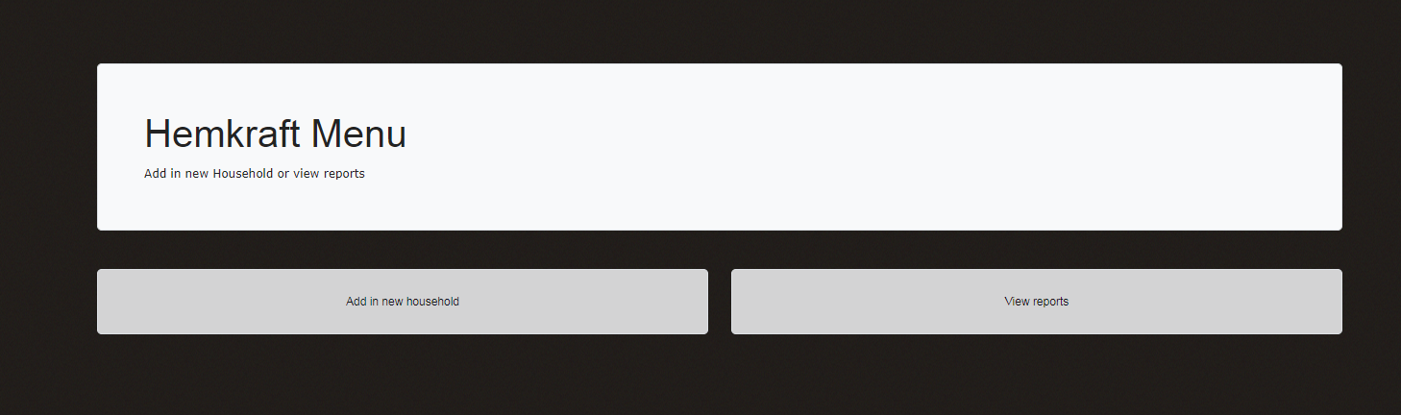

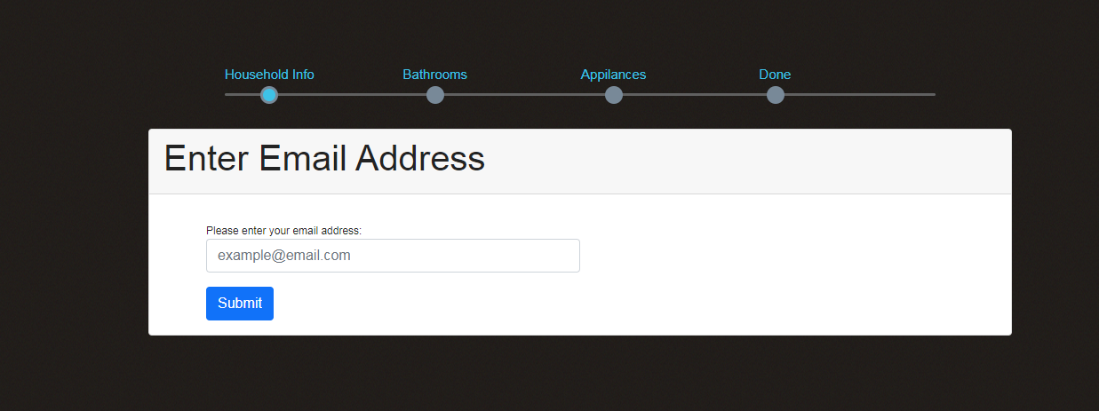

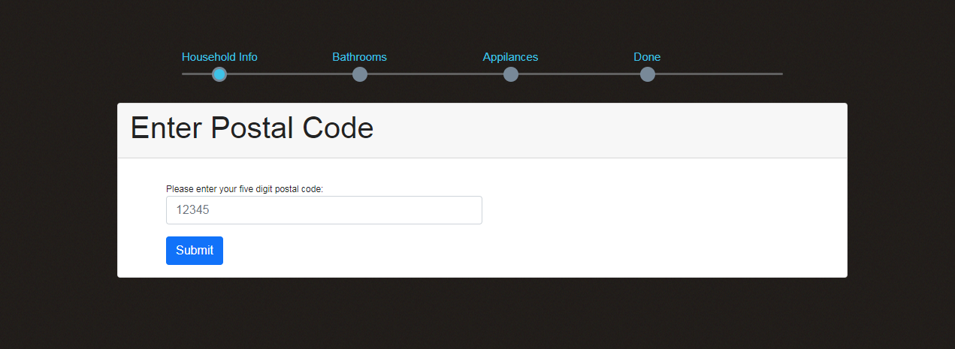

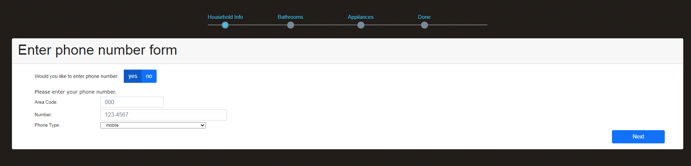

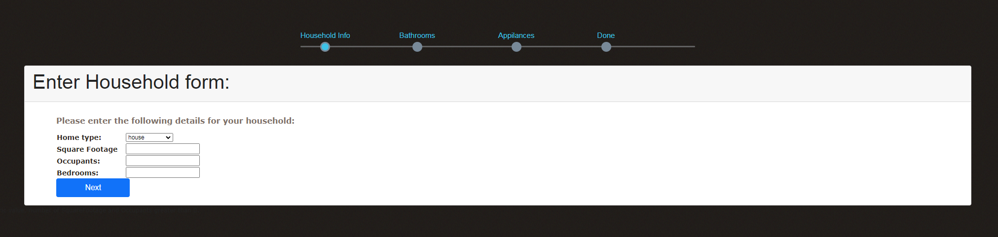

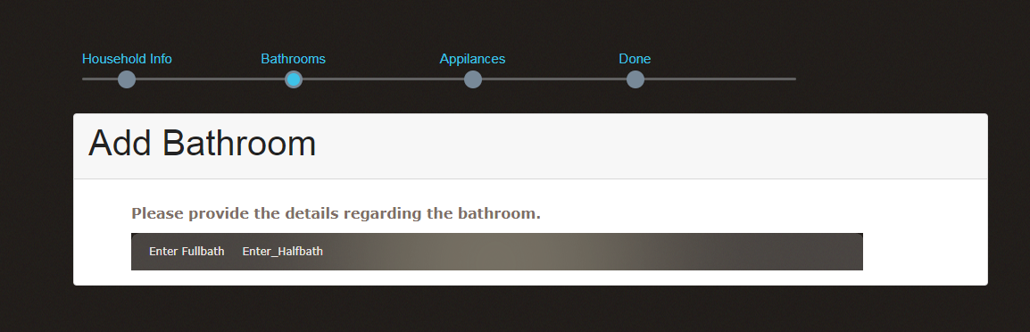

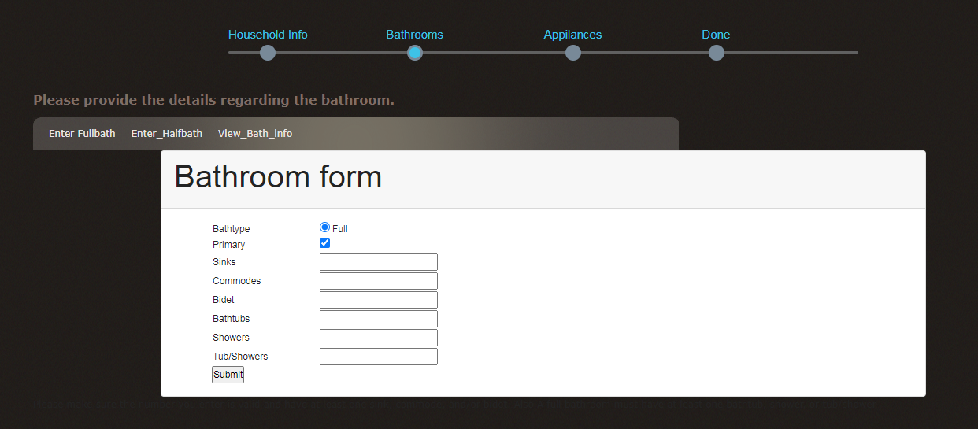

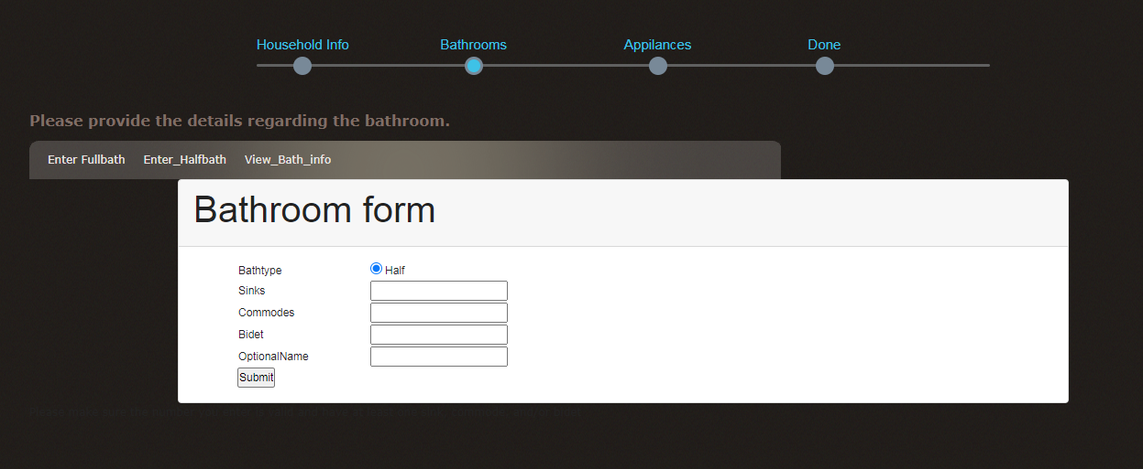

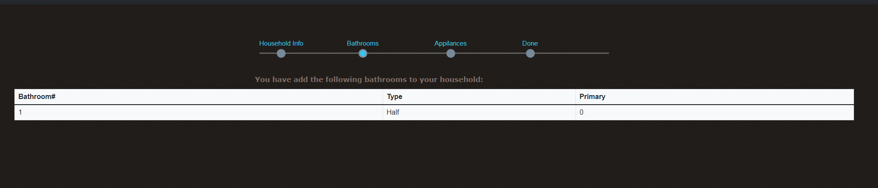

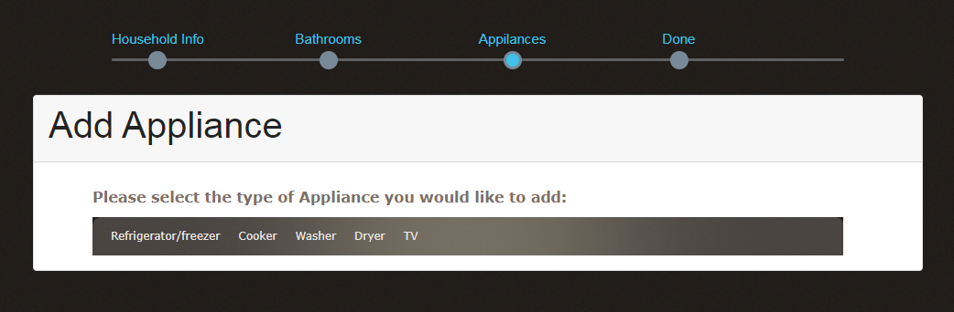

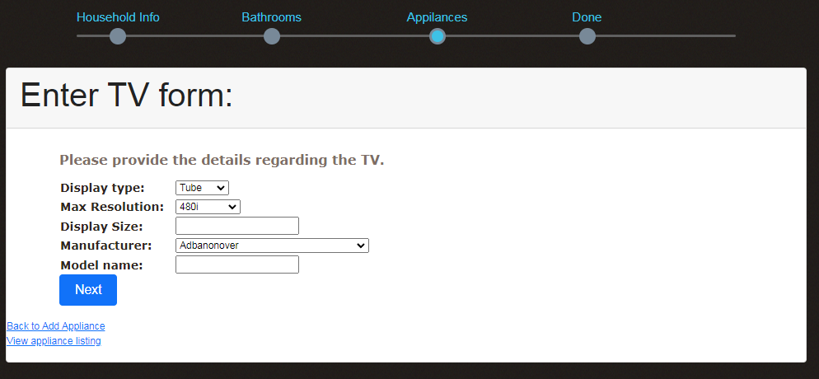

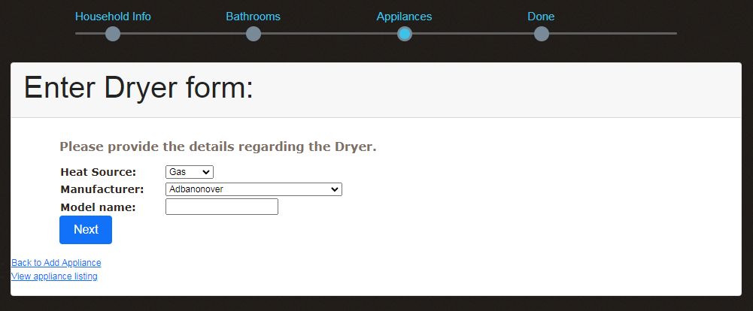

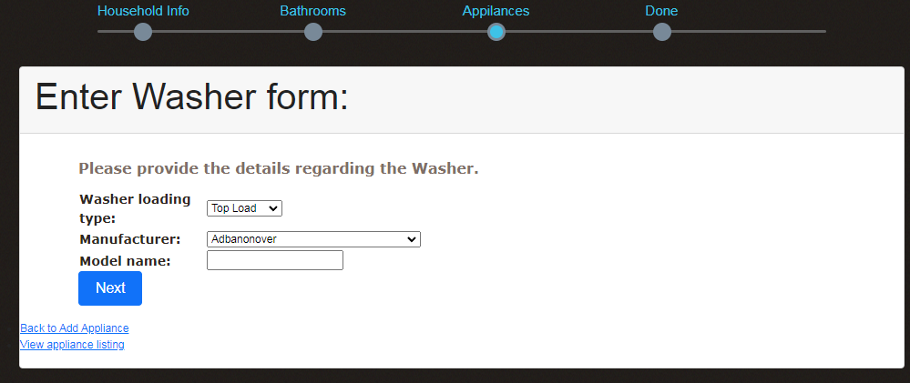

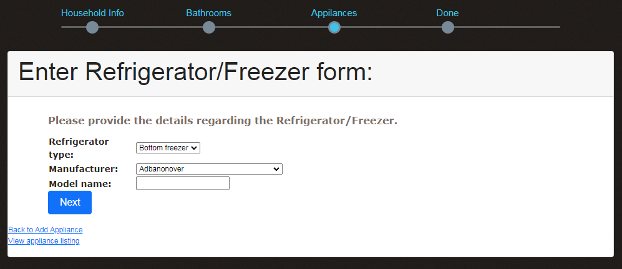

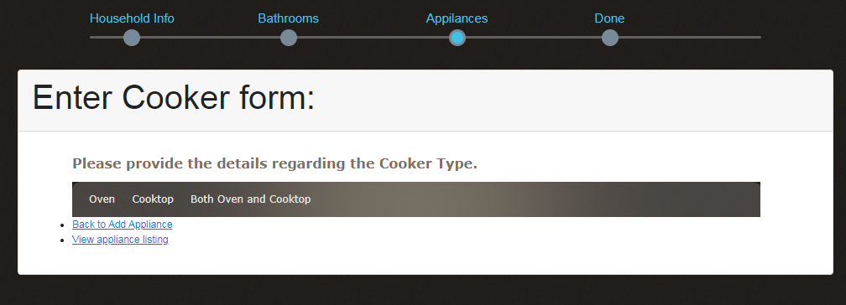

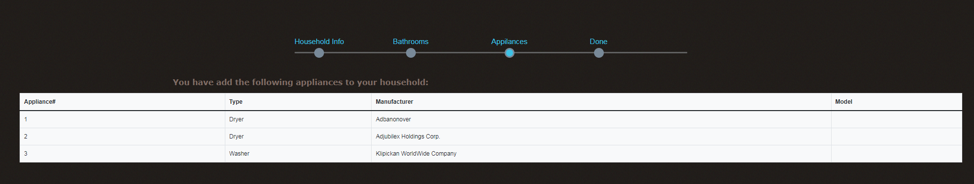

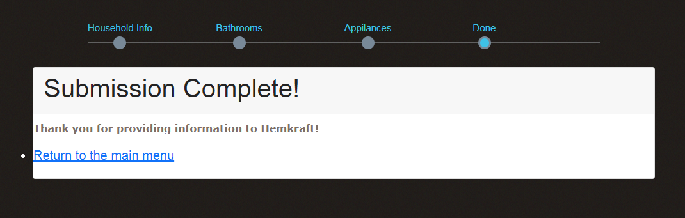

**List of Session Variables:**

Email is: $_SESSION['email']

Hometype is: $_SESSION['Hometype']

SquareFootage is: $_SESSION['SquareFootage']

Bathroom type: $_SESSION['bathroom_type'];

Primary bath: $_SESSION['PrimaryAvail'];

# of Occupants: $_SESSION['Occupants'];

# of Bedrooms: $_SESSION['Bedrooms'];

# of sinks: $_SESSION['num_sink'];

# of Commodes: $_SESSION['Commodes'];

# of Bidet $_SESSION['Bidet'];

# of Bathtubs: $_SESSION['Bathtubs'];

# of Showers: $_SESSION['Showers'];

# of Tub/Showers: $_SESSION['Tub/Showers'];

Model name is: $_SESSION['Modelname'];

Refrigerator type: $_SESSION['Refrigeratortype'];

Cooker Type: $_SESSION['CookerType'];

Oven Type: $_SESSION['OvenType'];

Oven Heat Source: $_SESSION['Oven_Heat_Source'];

Cooktop Heat Source: $_SESSION['Cooktop_Heat_Source'];

Dryer Heat source type: $_SESSION['Heatsourcetype'];

TV Display type: $_SESSION['Displaytype'];

TV Resolution: $_SESSION['Resolution'];

TV Display Size: $_SESSION['DisplaySize'];